Ice Cream Manager [ICM]

Use Case Specification Document

UC01

Modify Inventory

Version No. v0.3

Project Document Revision History

|  |  |  |  |
| --- | --- | --- | --- |
| Version | Date | Revision Author | Description of Revision |
| 0.1 | 2016-2-28 | Aly Lakhani | Initial content generation. |
| 0.2 | 2016-3-1 | Aly Lakhani | Added introduction, interactions, trigger, pre-conditions, post-conditions, flows of events |
| 0.3 | 2016-3-6 | Aly Lakhani | Updated actors, added assumptions and business rule, added use case diagram, and added table of figures |

Table of Contents

1.0 Introduction 4

2.0 Use Case Information 4

2.1 Actors 4

2.2 Use Case Interaction 4

3.0 Trigger 4

4.0 Pre-condition(s) 5

4.1 UC05 Process Batch File 5

4.2 UC10 Modify Presets 5

5.0 Post-condition(s) 5

5.1 UC04 Modify Truck 5

5.2 View Overall and/or Truck Inventory 5

6.0 Use Case Activity Diagram 6

7.0 Main/Basic Flow(s) of Events 7

7.1 Stock Depletion Manual Input 7

7.2 Stock Depletion Preset Applied 7

8.0 Alternate/Exception Flow of Events 7

8.1 Polling Data Updated 7

8.2 Ice Cream Goes Bad 7

9.0 Assumptions/Business Rules including Non-Functional Requirements 8

10.0 Use Case Specification Review and Signoff 8

Table of Figures

Diagram 1: Use Case Diagram 1 6

# 1.0 Introduction

The manager will be able to manually edit the inventory levels from here. This can also come from the inventory presets. Using this, the manager can increase, and/or decrease inventory levels for an ice cream truck(s), depending on the route the truck is travelling, the size of the truck, or custom user-entered inventories

# 2.0 Use Case Information

## 2.1 Actors

|  |  |  |
| --- | --- | --- |
| Actor Name | Role | Description |
| Manager | Main | The manager is the only person within the business who can directly interact with the inventories loaded per truck. |
| Processor | Secondary | The system that processes batch files |
|  |  |  |
|  |  |  |
|  |  |  |

## 2.2 Use Case Interaction

**Predecessors:** Process Batch File, Modify Presets, Modify Items, Modify Voting

**Successors:** Modify Truck

# 3.0 Trigger

* The manager entered inventory, or a text file with multiple inventory additions would trigger this use case, and set overall, and/or individual trucks accordingly.
* The manager could refresh the stock as the last used inventory, which would trigger this use case, and set the inventory levels to the same levels as were last used.
* If a preset were applied, that would also trigger this use case, and set the truck(s) inventory levels accordingly.
* If new polling data gives information about new items to be added or popularity of another item, the manager may want to update the inventories for that specific route, which he could use the preset for or enter manually, which would trigger this use case.
* If the manager chose to view the inventory, whether the overall, or just for a specific truck, this use case would be invoked.
* If product(s) were to go past the date of expiration and the manager needed to manually update the inventory accordingly, that would trigger this use case.
* If one of the ice cream trucks were to break down, the manager would need to salvage the ice cream and make sure to take out that truck out of all inventories reloads until repaired. Also may need to put more inventories in other trucks if those trucks are assigned the route of a broken down truck.

# 4.0 Pre-condition(s)

These are the other use cases or other pre-conditions that must be met before this use case can initiate

## 4.1 UC05 Process Batch File

As long as this use case is fulfilled correctly, and the batch file is correctly loaded, and the trucks and items were correctly initialized and the inventory parameter was specified, and specified correctly then this use case will be able to process the data and perform the next steps in assigning the inventory.

## 4.2 UC10 Modify Presets

If the preset has been made correctly and has been chosen to be applied then this use case will be able to process that data and set inventory in trucks according to truck or route preset. This is not a necessary pre-condition in order for the Modify Inventory use case to work; however in order for the preset option to work within this use case, this condition must be met prior to using it.

# 5.0 Post-condition(s)

These are the possible output states upon completion of the use case flows.

## 5.1 UC04 Modify Truck

The inventory on the truck will be updated after this use case is complete.

## 5.2 View Overall and/or Truck Inventory

The manager will be able to view the overall inventory or the inventory for a selected truck.

# 6.0 Use Case Activity Diagram

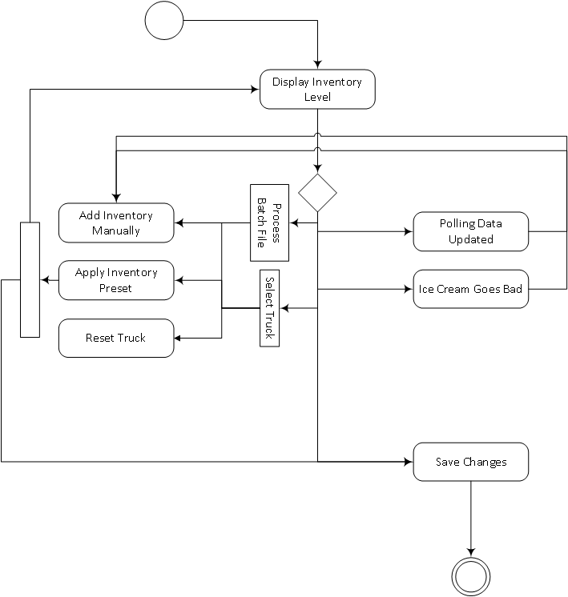

Diagram 1: Use Case Diagram

# 7.0 Main/Basic Flow(s) of Events

## 7.1 Stock Depletion Manual Input

1. Stock is depleted.

2. Manager will make a decision to add as much inventory as they would like.

3. They can also press the refresh stock button and reload the last used inventory levels for the selected truck.

4. Save Changes.

5. The inventories are modified for the truck(s).

## 7.2 Stock Depletion Preset Applied

1. Stock is depleted.

2. The manager will be able to select one of the presets they already have created and apply that.

3. They can also press the refresh stock button and reload the last used inventory levels for the selected truck.

4. Save Changes.

5. The inventories are modified for the truck.

# 8.0 Alternate/Exception Flow of Events

## 8.1 Polling Data Updated

1. Latest polling data is received and analyzed.

2. The manager will manually update the inventories per truck depending on which truck corresponds to which route it is assigned to.

3. The truck’s inventory will be modified.

## 8.2 Ice Cream Goes Bad

1. Ice cream goes beyond its expiration date.

2. The manager will update the inventory manually. The truck’s inventory will then be modified.

# 9.0 Assumptions/Business Rules including Non-Functional Requirements

UC01-1. Modifying the inventory should be processed within 1 second, or provide a progress bar otherwise.

# 10.0 Use Case Specification Review and Signoff

Review and Signoff of the Use Case Specification

|  |  |  |  |
| --- | --- | --- | --- |
| Name | Project Team Role | Signature | Date |
| Camille Williams | Project Manager |  |  |
| Marc King | Team Lead |  |  |
|  |  |  |  |